**Authentification :**

POST = https://site.yasmineinfo.com/api/

{

"action": "auth",

"login":"migo",

"password":"12654"

}

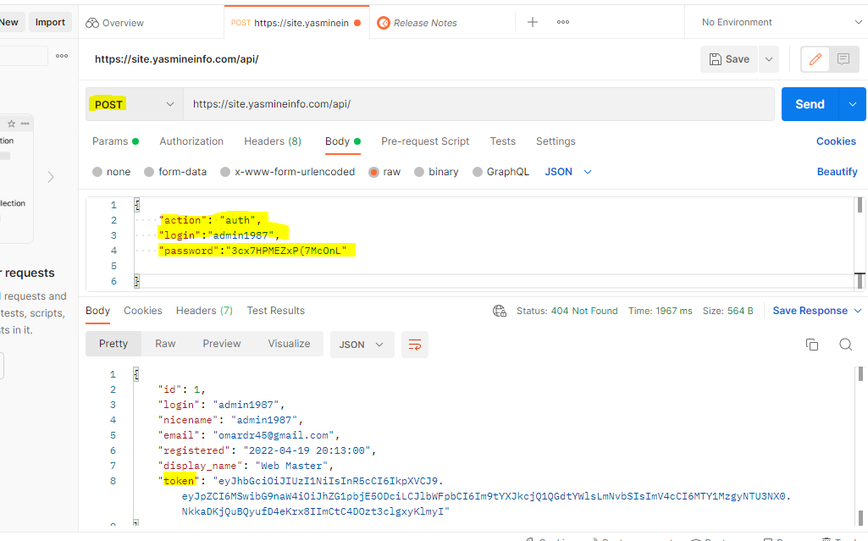

**Tous les commandes**

POST = https://site.yasmineinfo.com/api/

{

"action": "orders",

"token":"",

}

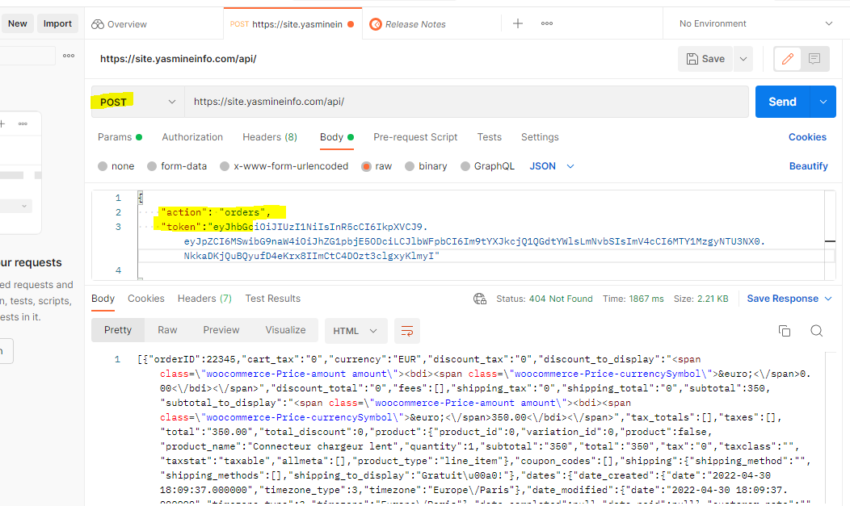

**Ajouter voiture**

POST = https://site.yasmineinfo.com/api/

{

"action": "new_car",

"brand": "test",

"name": "testnam",

"type": "testtype",

"registration": "testreg",

"token":"",

}

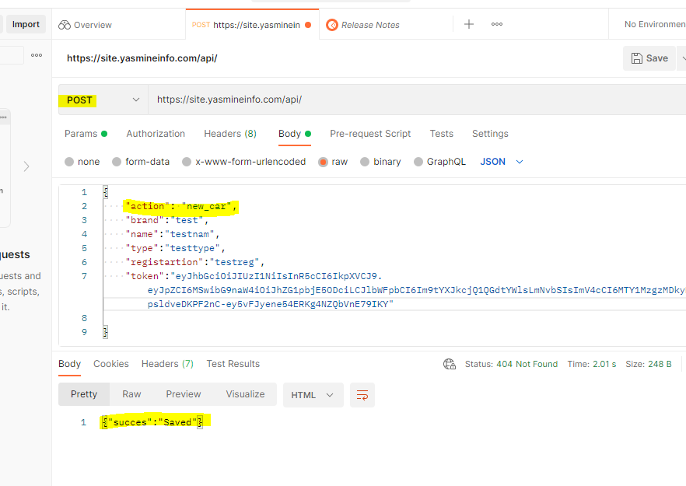

**Récupérer les voitures**

POST = https://site.yasmineinfo.com/api/

{

"action": "mycars",

"token":"",

}

